# Trade Policy

A **trade policy** is a government policy that affects the number of goods and services a country exports and imports.

**Free trade** is when there are no government restrictions on trade.

**Protectionism** is when governments set trade restrictions to help domestic industries.

**Instruments of Trade Policy**

Most of the instruments of trade policy will sound familiar. They are tools that the government uses to implement the trade policy it has decided to use based on its economy's needs. Let's take a look at the major instrument of trade policy.

|  |  |
| --- | --- |
| **Instrument of Trade Policy** | **Definition** |
| Tariff | A tariff is a tax on an imported good or service. There are several types of [tariffs](https://www.studysmarter.co.uk/explanations/microeconomics/market-efficiency/tariffs/) such as an **ad Valorem tariff** which is a tariff based on the value of the good that is being imported. A **specific tariff** is a fixed per-unit rate that the importer pays on each item. A tariff is used to restrict imports since it raises the price of foreign goods. |
| [Import](https://www.studysmarter.co.uk/explanations/microeconomics/market-efficiency/import/) Quota | An import quota is a restriction on the amount of a good or service that can be imported in a set time frame. Under an **absolute quota**, once the limit is reached no more of the good can be imported. Under a **tariff-rate quota**, once the quota limit is reached, all goods after that are subject to higher tariff rates.A quota is used to restrict imports by limiting the quantity allowed in. |
| [Export](https://www.studysmarter.co.uk/explanations/microeconomics/market-efficiency/export/) Subsidy | An export subsidy is money paid by the government to exporters of a good. [Export](https://www.studysmarter.co.uk/explanations/microeconomics/market-efficiency/export/) subsidies can be **specific** meaning that it pays the exporter for every unit exported or they can be **ad Valorem** where the government pays the subsidy as a percentage of the good's total value. An export subsidy encourages the export of goods which increases domestic prices. |
| Voluntary Export Restraints (VER) | A VER is an export quota that restricts the quantity of a good that can be exported to another country. They are typically set in place after the *importing* country requests them. They want to avoid having the *importing* country set mandatory trade restrictions on the *exporting* country. A VER is not good for the domestic economy and it is good for the country that is importing the goods. Countries would prefer this voluntary and amiable solution to one that is more inflammatory like a quota or tariff. |
| Local Content Requirements (LCR) | A LCR is a trade policy that mandates that a portion of the goods that producers manufacture be produced domestically. This serves the purpose of reducing a country's dependence on international trade and provides opportunities for domestic [production](https://www.studysmarter.co.uk/explanations/microeconomics/production-cost/production/). |
| Other Trade Policies | There are other trade policies such as export credit subsidies, red-tape barriers, and government procurement that serve to benefit the citizens of the nation, be it economically or by protecting their health. |

### Comparison Chart

| **BASIS FOR COMPARISON** | **TARIFF BARRIERS** | **NON-TARIFF BARRIERS** |
| --- | --- | --- |
| Meaning | Tariff Barriers implies the taxes or duties imposed by the government on its imports, so as to provide protection to its domestic companies and increase government revenue. | Non-tariff barriers cover all the restrictions other than taxes imposed by the government on its imports, so as to provide protection to the domestic companies and discriminate new entrants. |
| Permissibility | World Trade Organization allowed the imposition of tariff barriers to its member nation but at a reasonable rate only. | World Trade Organization abolished the imposition of import quotas and voluntary export restraints. |
| Nature | Explicit | Implicit |
| Form | Taxes and Duties | Regulations, Conditions, Requirements, Formalities, etc. |
| Revenue | Government receives revenue | No revenue is received by the government |
| Affects | It affects the price of imported goods. | It affects the quantity or price or both of the imported goods. |
| Monopolistic Organizations | As the government charges import duty, monopolistic groups can be controlled. | The monopolistic organization charges high prices through low output. |
| Profit | High profits made by the importers can be controlled. | Importers can make more profits. |

# Types of International Strategies

There are three main international strategies available: (1) multidomestic, (2) global, and (3) transnational ([Figure 7.23 “International Strategy”](https://opentextbc.ca/strategicmanagement/chapter/types-of-international-strategies/#f7.23)).

# Multidomestic Strategy

A firm using a **multidomestic strategy** sacrifices efficiency in favor of emphasizing responsiveness to local requirements within each of its markets. Rather than trying to force all of its American-made shows on viewers around the globe, MTV customizes the programming that is shown on its channels within dozens of countries, including New Zealand, Portugal, Pakistan, and India.

[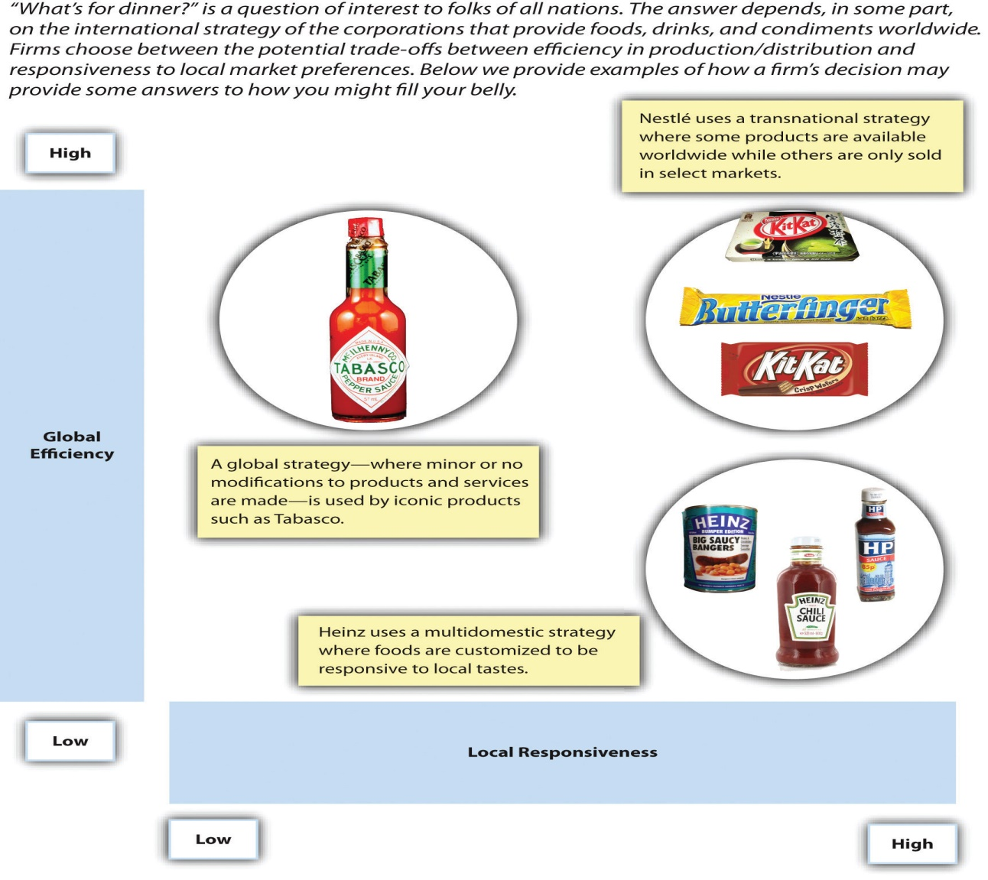](http://opentextbc.ca/strategicmanagement/wp-content/uploads/sites/30/2014/07/Figure-7-23.jpg)Figure 7.23: International Strategy[[Image description]](https://opentextbc.ca/strategicmanagement/chapter/types-of-international-strategies/#f7.23desc)

Similarly, food company H. J. Heinz adapts its products to match local preferences. Because some Indians will not eat garlic and onion, for example, Heinz offers them a version of its signature ketchup that does not include these two ingredients.

[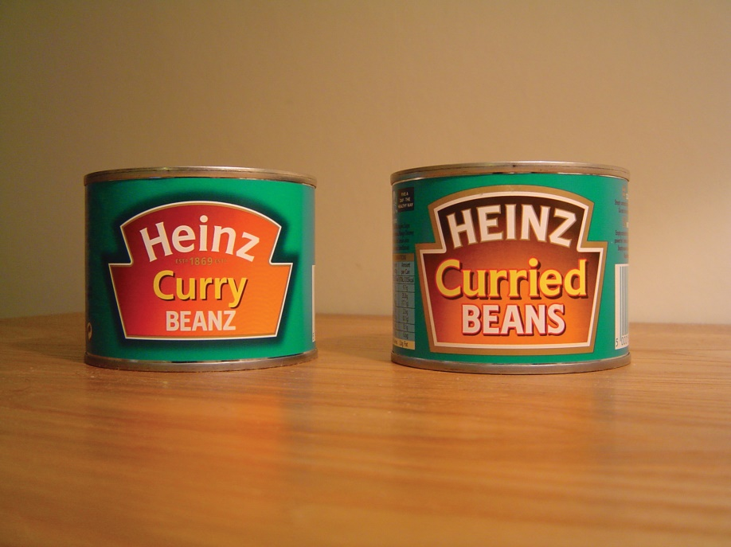](http://opentextbc.ca/strategicmanagement/wp-content/uploads/sites/30/2014/07/heinz-curry-beans.jpg)Figure 7.24: Baked beans flavored with curry? This H. J. Heinz product is very popular in the United Kingdom.

# Global Strategy

A firm using a **global strategy**sacrifices responsiveness to local requirements within each of its markets in favor of emphasizing efficiency. This strategy is the complete opposite of a multidomestic strategy. Some minor modifications to products and services may be made in various markets, but a global strategy stresses the need to gain economies of scale by offering essentially the same products or services in each market.

Microsoft, for example, offers the same software programs around the world but adjusts the programs to match local languages. Similarly, consumer goods maker Procter & Gamble attempts to gain efficiency by creating global brands whenever possible. Global strategies also can be very effective for firms whose product or service is largely hidden from the customer’s view, such as silicon chip maker Intel. For such firms, variance in local preferences is not very important.

# Transnational Strategy

A firm using a **transnational strategy** seeks a middle ground between a multidomestic strategy and a global strategy. Such a firm tries to balance the desire for efficiency with the need to adjust to local preferences within various countries. For example, large fast-food chains such as McDonald’s and KFC rely on the same brand names and the same core menu items around the world. These firms make some concessions to local tastes too. In France, for example, wine can be purchased at McDonald’s. This approach makes sense for McDonald’s because wine is a central element of French diets.

## What Is a Multinational Corporation?

A multinational corporation (MNC) is a company that has business operations in at least one country other than its home country. By some definitions, it also generates at least 25% of its [revenue](https://www.investopedia.com/terms/r/revenue.asp) outside of its home country.

Generally, a multinational company has offices, factories, or other facilities in different countries around the world as well as a centralized headquarters which coordinates global management.

Multinational companies can also be known as international, stateless, or transnational corporate organizations or enterprises. Some may have budgets that exceed those of small countries.

## Characteristics of a Multinational Corporation

Some of the characteristics common to various types of multinational corporations include:

* A worldwide business presence
* Typically, large and powerful organizations
* Business conducted in various languages
* A complicated business model and structure
* Direct investments in foreign countries
* Jobs created in foreign countries, potentially with higher wages than found locally
* Seeks improved efficiencies, lower production costs, larger market share
* Has substantial expenses associated with navigating rules and regulations of foreign countries
* Pays taxes in countries in which it operates
* Reports financial information according to [International Financial Reporting Standards](https://www.investopedia.com/terms/i/ifrs.asp) (IFRS)
* Sometimes accused of negative economic and/or environmental impacts in foreign markets
* Sometimes accused of negative economic impacts in home country due to outsourcing jobs